Exp No: 01 Name: Karthikeyan A
Date: 18-08-2023 Reg No: 3122 21 5001 041
------------------------------------------------------------------------------------------------------------------------
Study of network system commands and calls
------------------------------------------------------------------------------------------------------------------------
Aim:
Study of network system commands and calls.

Command: ifconfig

Description:
The ifconfig function displays the current configuration for a network interface when no optional parameters are supplied

Syntax: ifconfig interface [ addressfamily [ address [ destinationaddress ] ] [ parameters... ] ]

Explanation:
You can use the ifconfig command to assign an address to a network interface and to configure or display the current network interface configuration information. The ifconfig command must be used at system startup to define the network address of each interface present on a system. After system startup, it can also be used to redefine an interfaces address and its other operating parameters. The network interface configuration is held on the running system and must be reset at each system restart. The ifconfig command interprets the IFF_MULTICAST flag and prints its value if it is set.

Options:
Item | Description
-a | Display information about all interfaces in the system
-s | Display a short list
-v | be more verbose for some error conditions

Return Value:
- 0 – Success
- 1 – Syntax Error
- 2 – Kernel Error

Example:
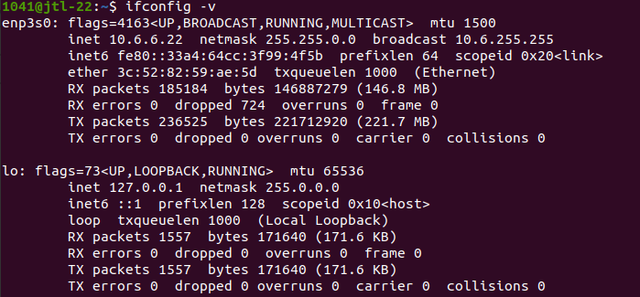

Command: tcpdump

Description:
Tcpdump is a network capture and protocol analysis tool.

Syntax: ifconfig interface [ addressfamily [ address [ destinationaddress ] ] [ parameters... ] ]

Explanation:
tcpdump is a packet sniffing and packet analyzing tool for a System Administrator to troubleshoot connectivity issues in Linux. It is used to capture, filter, and analyze network traffic such as TCP/IP packets going through your system. It is many times used as a security tool as well. It saves the captured information in a pcap file, these pcap files can then be opened through Wireshark or through the command tool itself.

Options:
Item | Description
-A | Print a echo packet in ASCII.
-c | Exit after ewcwiving coutn packets.
-dd | Dump packet-matching code as a c program fragment.

Return Value:
- 0 – Success
- else – Error

Example:

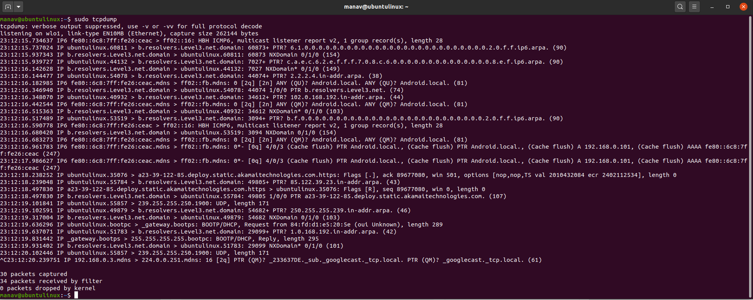
Command: nslookup

Description:
Nslookup is a useful command for getting information from the DNS server.

Syntax:
nslookup [option] [hosts]

Explanation:
Nslookup stands for Name Server Lookup.It is a network administration tool for querying the Domain Name System (DNS) to obtain domain name or IP address mapping or any other specific DNS record. It is also used to troubleshoot DNS-related problems.

Options:

Option | Description
all | Prints the current values of the frequently used options to set. Information about the current default server and host is also printed.
[no]debug | Turns debugging mode on. The default is nodebug.
domain=name | Changes the default domain name to the name specified by the name parameter.

Return value:

1 - if any query failed
0 – otherwise
Example:
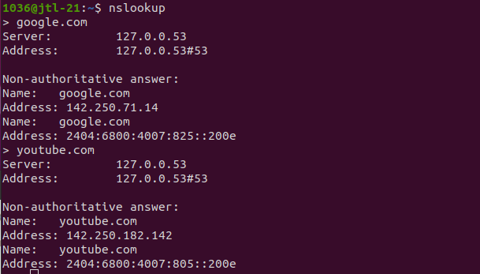

Command: netstat

Description:
The netstat command displays the contents of various network-related data structures for active connections.

Syntax: netstat [ -n ] [{-A -a } | { -r -C -i -I Interface } ] [ -f AddressFamily] [ [ -p Protocol ] | [ -@ WparName ] ] [ Interval ]

Explanation:
The netstat command symbolically displays the contents of various network-related data structures for active connections. The Interval parameter, which is specified in seconds, continuously displays information regarding packet traffic on the configured network interfaces. The Interval parameter takes no flags.

Options:
Item | Description
-A | Enables socket level debuggingShows the address of any protocol control blocks associated with the sockets.
-a | Shows the state of all sockets
-g | Shows Virtual Interface Table and Multicast Forwarding Cache information.

Example:
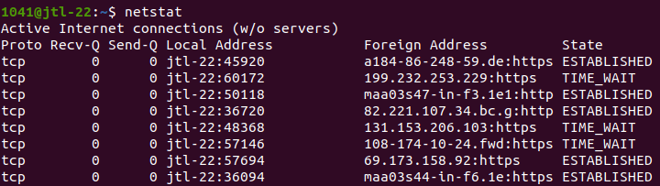

Command: traceroute

Description:
Traceroute works by sending Internet Control Message Protocol (ICMP) packets, and every router involved in transferring the data gets these packets.

Syntax: traceroute [ -m Max_ttl ] [ -n ] [ -p Port ] [ -q Nqueries ] [ -r ] [ -d ] [ -g gateway_addr ] [ -s SRC_Addr ] [ -t TypeOfService ] [ -f flow ] [ -v ] [ -w WaitTime] Host [ PacketSize ]

Explanation:
The traceroute command attempts to trace the route an IP packet follows to an Internet host by launching UDP probe packets with a small maximum time-to-live (Max_ttl variable), then listening for an ICMP TIME_EXCEEDED response from gateways along the way. Probes are started with a Max_ttl value of one hop, which is increased one hop at a time until an ICMP PORT_UNREACHABLE message is returned. The ICMP PORT_UNREACHABLE message indicates either that the host has been located or the command has reached the maximum number of hops allowed for the trace.

Options:
Item | Description
-d | Enables socket level debugging
-f | Sets the flow label field in IPv6 packet header. The default value is 0.
-n | Prints hop addresses numerically rather than symbolically and numerically.

Example:
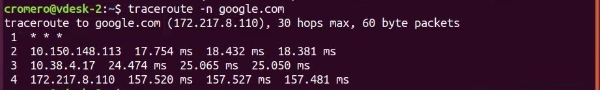

Command : ping

Description:
ping is the primary TCP/IP command used to troubleshoot connectivity, reachability, and name resolution.

Syntax:
ping [ -d] [ -D ][ -n][ -q][ -r][ -v][ -R] [ -a addr_family ][ -cCount] [ -w timeout ][ -f| -iWait][ -lPreload][ -pPattern] [ -sPacketSize] [ -S hostname/IP addr ][ -L ] [ - I a.b.c.d. ] [ -o interface ] [ -T ttl ] Host [ PacketSize] [ Count]

Explanation:
The ping command sends one datagram per second and prints one line of output for every response received. The ping command calculates round-trip times and packet loss statistics, and displays a brief summary on completion. The ping command completes when the program times out or on receipt of a SIGINT signal. The Host parameter is either a valid host name or Internet address. By default, the ping command will continue to send echo requests to the display until an Interrupt is received (Ctrl-C). The Interrupt key can be changed by using the stty command.

Options:

Item | Description
-c Count | Specifies the number of echo requests, as indicated by the Count variable, to be sent (and received).
-w timeout | This option works only with the -c option. It causes ping to wait for a maximum of 'timeout' seconds for a reply (after sending the last packet).
-d | Starts socket-level debugging.
-D | This option causes a hex dump to standard output of ICMP ECHO_REPLY packets.

Return values:

0 - Success(destination is reachable)
1 – Failure(destination is not reachable)

Example:

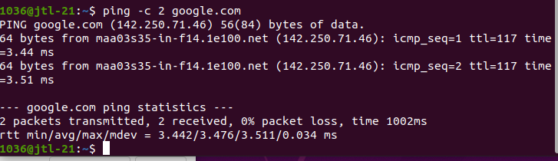

System calls

------------------------------------------------------------------------------------------------------------------------

System call name: socket - create an endpoint for communication

Description:
socket() creates an endpoint for communication and returns a file descriptor that refers to that endpoint.

Header files: <sys/socket.h> and <sys/types.h>

Syntax: int socket(int domain, int type, int protocol);
a. The domain argument specifies a communication domain; this selects the protocol family which will be used for communication.
b. the type argument serves a second purpose: in addition to specifying a socket type,
c. The protocol specifies a particular protocol to be used with the socket.

Explanation of parameters:
Name | Purpose
domain
AF_UNIX | Local communication
AF_INET | IPv4 Internet protocols
AF_INET6 | IPv6 Internet protocols
type
SOCK_DGRAM | Supports datagrams
SOCK_STREAM | Provides sequenced, reliable, two-way, connection-based byte streams.
SOCK_SEQPACKET | Provides a sequenced, reliable, two-way connection based data transmission path for datagrams of fixed maximum length
SOCK_RAW | Provides raw network protocol access.

Return Value:
On success, a file descriptor for the new socket is returned. On error, -1 is returned, and errno is set appropriately.

System call name: bind - bind a name to a socket

Description:
bind() assigns the address specified by addr to the socket referred to by the file descriptor sockfd

Header files: <sys/socket.h> and <sys/types.h>

Syntax: int bind(int sockfd, const struct sockaddr *addr, socklen_t addrlen);
- sockfd: The socket file descriptor to be bound.
- addr: A pointer to a structure containing the local address information (IP address and port).
- addrlen: The length of the addr structure in bytes.

Return Value:
On success, zero is returned. On error, -1 is returned, and errno is set appropriately.

